PowerWash Wisdom Site Plan

Zelda Asvitt

WDD 130

Overview

Purpose
To educate people on the benefits of power washing and answer all questions concerning which models should be purchased and how to generally operate and use a power washer.

Audience
Adults interested in maintaining their homes, Teens interested in good summertime gigs and anyone who has wanted to get into power washing but had no idea where to start?
Elevator Pitch
My website explores how power washing can transform surfaces, extend the life of outdoor materials, and improve home value through proper cleaning techniques. It will include clear explanations of the benefits of pressure washing, step-by-step guidance on safe and effective methods, and a practical tool to help users choose the right type of pressure washer based on their budget, surface types, and cleaning goals. What makes this site unique is its blend of beginner-friendly instruction and personalized recommendations, helping users avoid common mistakes while feeling confident in their equipment choices. It’s designed to be both educational and empowering, giving visitors everything they need to clean smarter, safer, and more efficiently.

OVERALL NOTE: Please Reach Out to Me as You Work, I am very iffy on the text blurbs and will happily revise. All wireframes are a guide and can be ignored or adapted if the vibes are off
Additional INFO: I intentionally used only one image and a guide because that is what is expected when making pages similar to what I have planned. I referenced a couple of different pages, and they kept the images sparce.

Branding

Website Logo
 I would like the name written either to the sides or underneath the image anytime logo is mentioned. I wanted them to be in two separate parts to fit the vibes of each individual use. Use the Chango font listed below and preferable have the words “PowerWash” stacked on top of “Wisdom”.

Style Guide

Color Palette
Primary | Secondary | Accent 1 | Accent 2
#0d99ff | #124559 | #0cc0df | #598392

Typography

Heading Font: Chango (Google Font)

Paragraph Font: Nunito (Google Font)

Backup for both : Trebuchet MS

Navigation
Home What Model? How?

Content

[put all content for the pages here, including written text and images]

Home
[home page content and images here]

What YOU Stand to Gain by Pressure Washing (heading)
Title: Save Money on Repairs
P: Learning to Power wash will save you money. Power washing safely cleans and removes mold, algae, and dirt that weakens and wears down house, leading to weakened foundations, holes and more. Power washing is a preventative measure you can take to increase the life of your buildings and outdoor furniture. For this same reason, you also save money as you won’t need to replace furniture.

Title: Save Time and Money on Cleaning
P: Power washing safely cleans stubborn messes and stains without needing the use of extra soaps or chemicals. It is safe to use on all materials, assuming you approach it correctly, as it just uses water. It is also more efficient than cleaning by hand, as it saves time, effort, and even water consumption. Pressure washers of all makes use less water than using a normal hose. This is because it concentrates the water, shooting a small amount at high velocity. This is also what gives it its cleaning power.

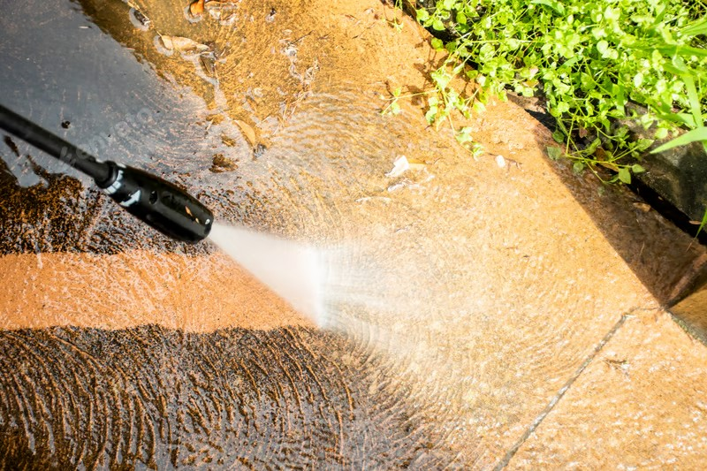
Size this however you want, but the nozzle and one of the dirty segments must be visible to show case proper cleaning angles and the difference between the cleaned and dirty area.
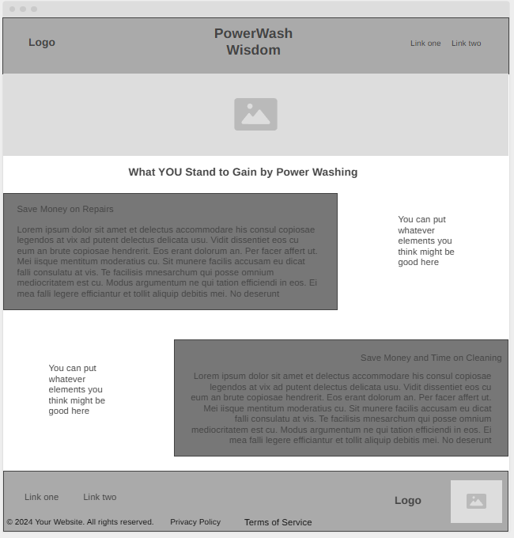

Page 1 What Model
 | Electric | Gasoline
Easier to Use | x
Higher Power | - | x
Louder | - | x
Quieter | x | -
Should be stored Safely | x | x
Less Durable, Less Maintenance | x | -
More Durable More Maintenance | - | x
Light Duty | x | -
Heavy Duty | - | x
More Affordable | x | -
Life Span | 3-5 Years | 5-7 years

Picking a power washer can be a challenging thing, each one seeming similar, but just different enough. Using this chart will be able to help you narrow down your choice and make it easier to find a model that suits your needs. For example, if you wanted to make a side gig out of power washing and know you’ll be using it frequently in a variety of locations, then a gas washer is likely best for you. Meanwhile, if you live in a closely packed neighborhood, you might opt for an electric washer.
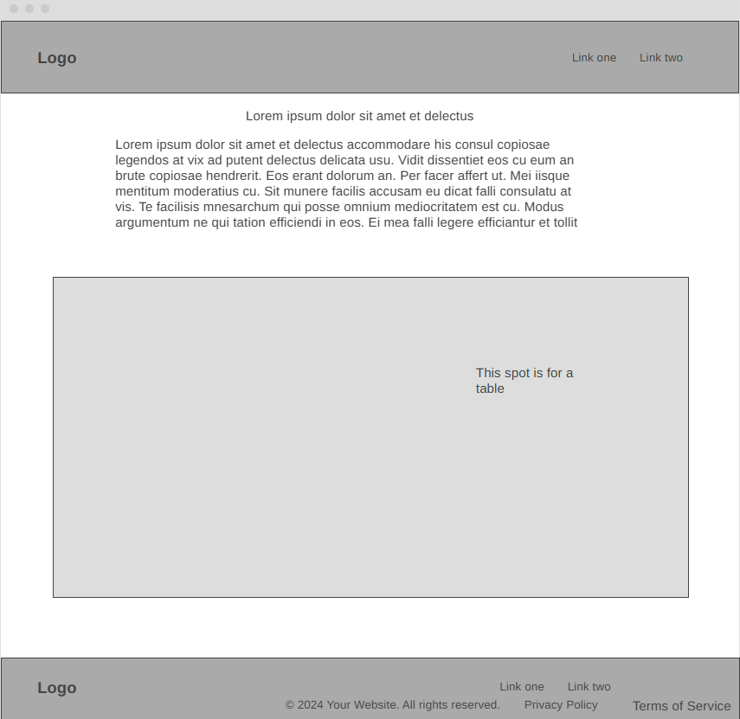

How?
[page 2 content and images here]

How to Power Wash
- First and Foremost, READ THE MANUAL. While there are some general tips for all power washers, knowing how to start, use, turn off and maintain yours is going to be the most important thing. The only way to achieve this is to READ the MANUAL that COMES with your POWER WASHER.
- The next most important thing is to make sure you are properly equipped. Power washers shoot water at intense speeds, and are strong enough to cut through skin, muscle, and even bone if the pressure is strong enough. Luckily a pair of RUBBER BOOTS is enough to prevent this. Make sure to ALERT PEOPLE who may be moving around or NEAR before you begin.
- Wear clothes, you don’t mind getting wet and dirty. There will be a decent amount of spray flung back at you after it hits the surface you are cleaning. It won’t be strong enough to be noticed but it will make you dirty
- When you open the machine, it will have multiple different colored nozzles. Refer to your manual and start with the one that is the lowest PSI. This will be the gentlest nozzle. You can move up from there if it is not strong enough.
- Always start cleaning in a nondescript or hidden corner, to make sure the object itself is not going to be damaged
- If you elect to use soap, only use the soap nozzle and make sure that all soap has left the machine before swapping back to a higher-pressure nozzle. You will break your machine if you do not.
- NEVER use the washer with the NOZZLE POINTED DIRECTLY DOWN. This will embed the dirt into the surface, making it nearly impossible to clean. INSTEAD, hold the nozzle AT AN ANGLE. This ensures the dirt will be removed without becoming embedded.
- Remember the dirt has to go somewhere, so start at the top of the area you are cleaning and work down. Otherwise, you will just be running dirt over the area you have just cleaned. In this same vein, keep in mind the direction the water is draining at ground level and start away from it and works towards it.
- Practical Tip: Crouch or squat, when possible, instead of bending over. The nozzle will be slightly heavy and will be vibrating constantly. Spare your back and crouch or squat when needed.
